PThrussell’s project portfolio

https://github.com/PThrussell74/PThrussellPortfolio

|  |  |  |  |  |  |  |  |  |
| --- | --- | --- | --- | --- | --- | --- | --- | --- |
| **Project** | **HTML / CSS** | **Java** | **JavaScript** | **C#** | **C++** | **Android** | **SQL** | **ASP.NET** |
| Irrigation |  | X |  |  | X | X | X |  |
| Banger | X | X |  |  |  |  | X |  |
| POS |  | X |  |  |  | X | X |  |
| Event Planning |  |  |  | X |  |  |  |  |
| ColourCore |  |  | X |  |  |  |  |  |
| Contoso | X |  |  | X |  |  |  | X |
| Angelic Pete | X |  | X |  |  | *1 |  |  |

*1: Has a mobile friendly version of the website

## Automated plant irrigation with app configuration and cloud integration

**Features:** C++ (Arduino), Java, Android, SQL, Design patterns, Spiral Method

**Origin:** Final Year Project (2021), original project

**Aim:** To create an automatic irrigation system controllable via mobile using Spiral development

**Grade:** 77% (including viva voce, literary review, and project report)

The irrigation **IoT** project was started during the final year of university for the purpose of demonstrating the possibilities of creating an automatic irrigation system for domestic users at a low price using **spiral** development. This was achieved using **RESTful** web services with **SQL** commands on a **JavaDB** database. The physical unit consisting of sensors, an ethernet port and a solenoid were created using **Arduino**. The mobile app using **Android** studio allowed remote monitoring of the plant’s readings and to alter thresholds.

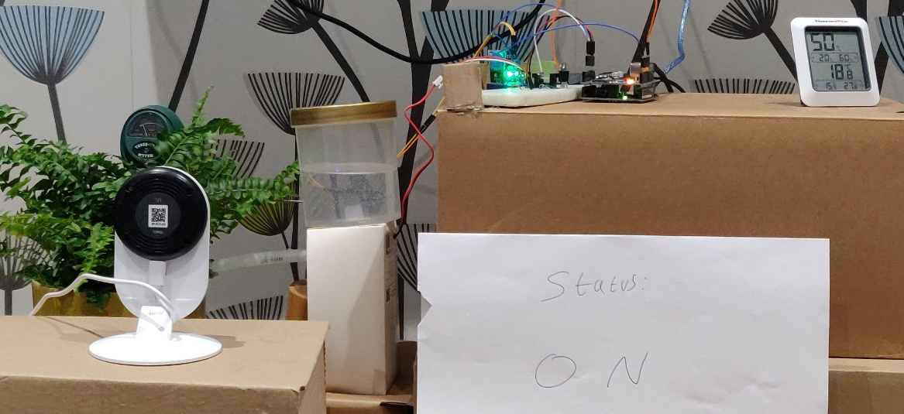

*An image of the irrigation system set-up and running.*

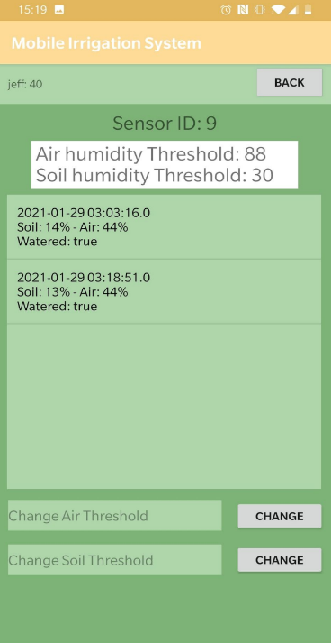

*An image of the mobile application with readings.*

## Banger’s car rental online solution, version 2

**Features:** Java, HTML, CSS, SQL, Design patterns

**Origin:** Final Year university module (2021), modification of existing project

**Aim:** To develop an online booking system and showcase different functions in Java.

**Grade:** 84% (including a project report)

The mock client issued a statement on what features should be implemented in their online booking system. Using **RESTful** web services powered by **JavaDB** and **SQL** in NetBeans, a **Java** and **HTML** system was developed. Including an **E-Mail** **client**, a **CSV reader**, an **ABI reader**, an **Image to BLOB[]** method and a **web scraper** allowed Banger to notify the DVLA for any fraudulent activities via email, save details in a database when submitted online and most importantly, price their cars competitively by charging 5% less than their competitors automatically.

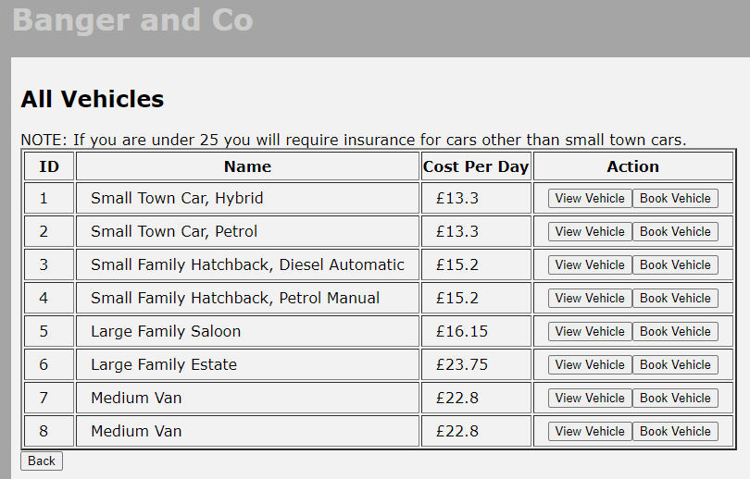

*An image of the vehicle booking page. The prices are decided from a rival website using a web scraper.*

## Mobile Product Ordering System

**Features:** Java, SQL, Android, Design Patterns

**Origin:** Final Year university module (2021), android implementation of existing project

**Aim:** To develop an app to order items, approve orders and ship orders.

**Grade:** 82.5% (including a project report)

A responsive and easy-to-use **Android** application was requested by the mock client which uses **Retrofit, Adapters** and **Fragments** so customers and admins can complete their business. Orders can be created by customers, then admins can fulfil, ship, and cancel orders if required.

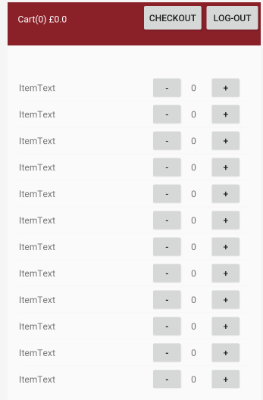

*An image of the basket page for the user, in Android Studio.*

## Event Planning System

***Features:*** *C#*

***Origin:*** *First Year university module (2018), original project*

***Aim:*** *To develop a system to take bookings and create events that can be booked.*

***Grade:*** *79% (including a project report)*

*Ordered by a mock client, this application takes bookings for events that can be created. Events are stored locally as this project is an early university project.*

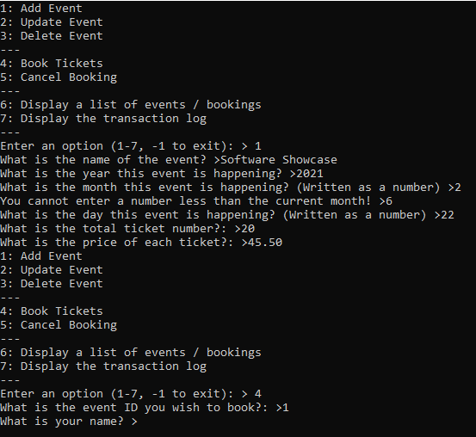

*An image of the program running.*

## ColourCore: TWICE

*NOTE: Code for this project will not be distributed as original code / concepts from this IP may be produced as a commercial game in the future. The patch-notes for the game as well as development details can be found on the Google Drive link below (Document length: 15,000 words)* [*https://docs.google.com/document/d/1aKgYD_3ZKDQvUvyW3oDgNi9d3Annbz5mKt6I4x438oo/edit?usp=sharing*](https://docs.google.com/document/d/1aKgYD_3ZKDQvUvyW3oDgNi9d3Annbz5mKt6I4x438oo/edit?usp=sharing)

***Features:*** *Javascript (basic), bespoke plugins, RPGMaker MV, Development Lifecycles*

***Origin:*** *COVID19 project (2020), original project*

***Aim:*** *To create a visual novel / RPG video game using existing IPs.*

***Grade:*** *N/A*

A passion project that is approaching its first anniversary since initial pre-alpha release. Although using “drag and drop” coding alongside **Javascript** (although very minimal), the aim of this project is to use **spiral methodology** combined with **heavy documentation** and testing using **patch-notes** to create a playable final product. All art, mesh and animations, programming (asides from plugins and libraries) and concepts (asides from inspiration and reference) are all created by hand as an **indie project**. Although the Javascript present in this project is minimal, it has been included to show my passion for development, documentation, and testing.

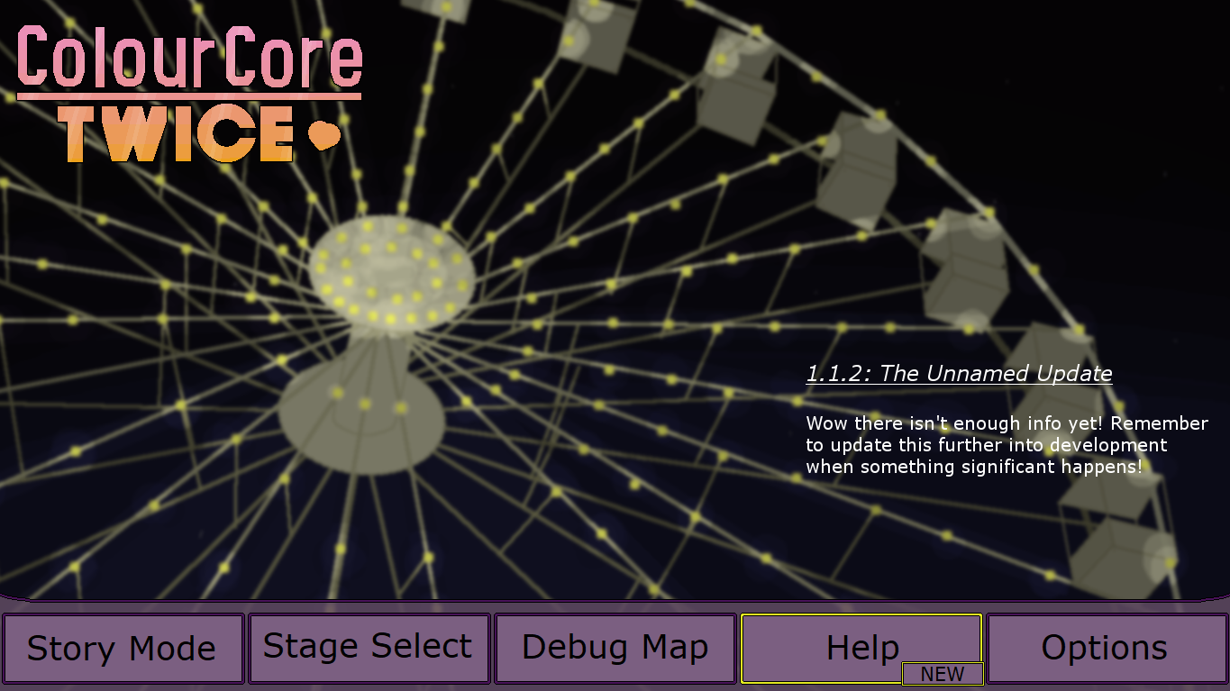

*The title screen of the game for the un-finished 1.1.2 update.*

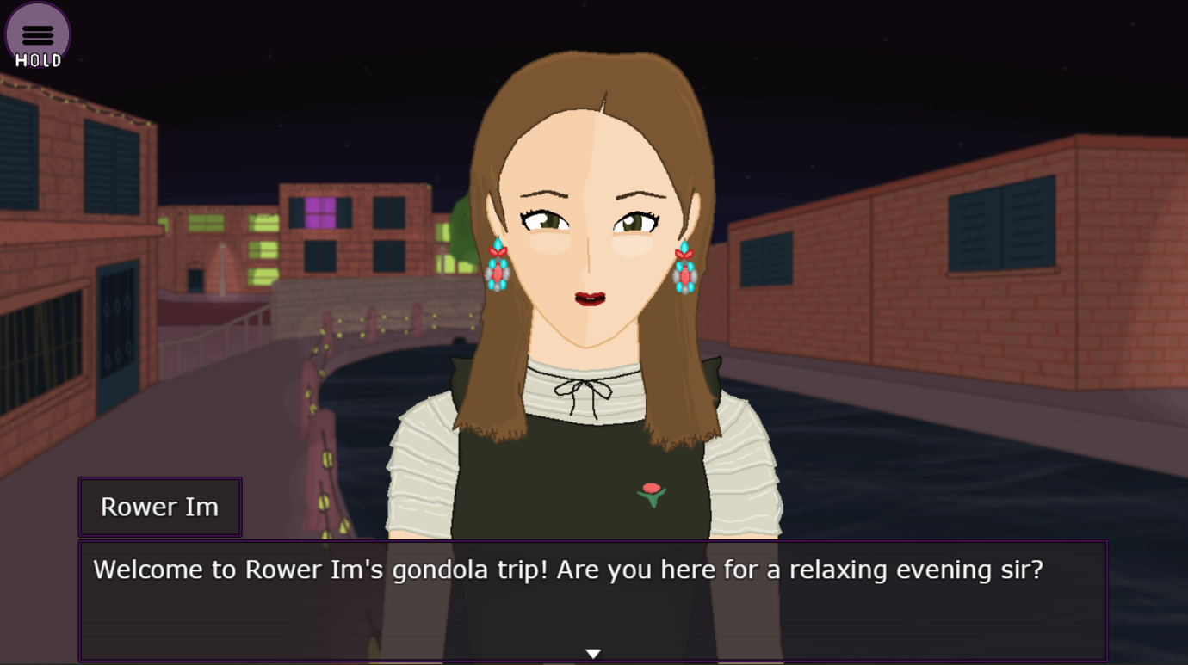

*A screenshot from the visual novel aspect of the game.*

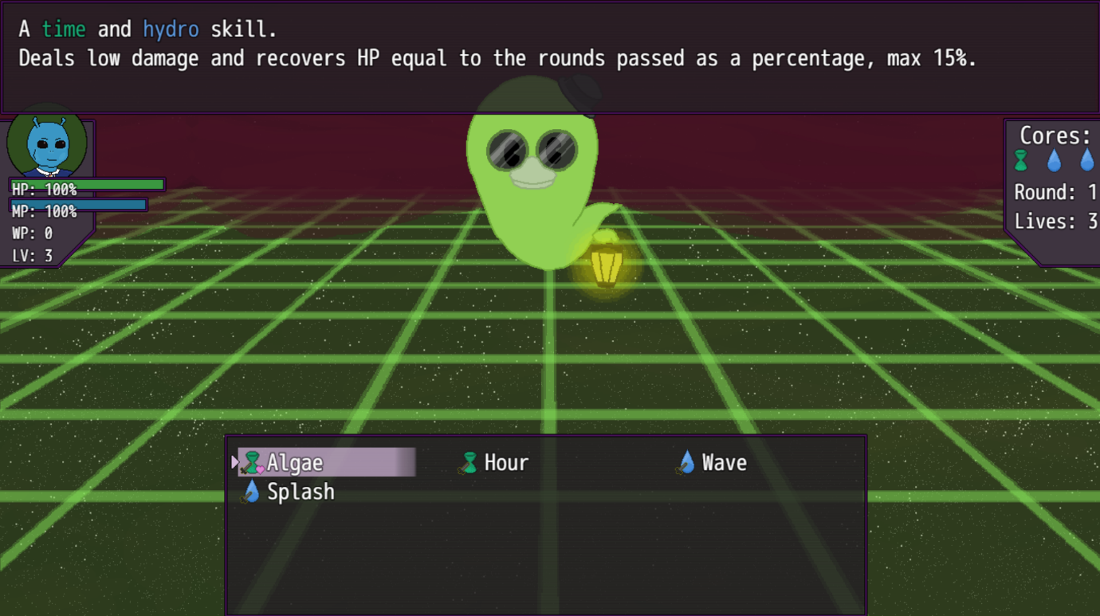

*A screenshot from the battle aspect of the game.*

## Contoso Crafts

***Features:*** *C#, ASP.NET, Javascript*

***Origin:*** *.net tutorial (2021)*

***Aim:*** *To study and learn how to use ASP.NET and better C# skills.*

***Grade:*** *N/A*

A project that was started to learn **ASP.NET** to create web pages that use a mix of **Javascript**, **C#** and **Razor**.

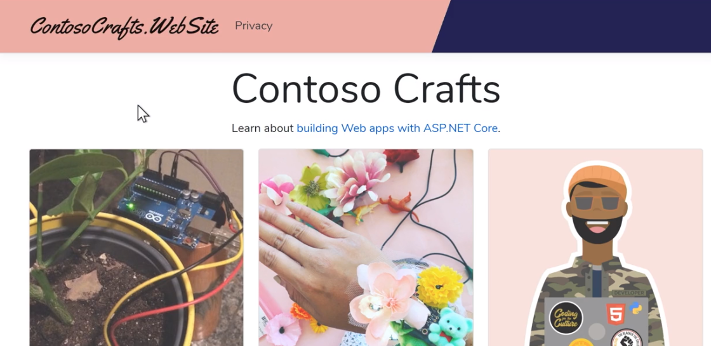

*An image of the website.*

## Angelic Pete

*Note: This project was saved on a drive at Staffordshire University before COVID-19 begun and is considered lost media since 07/07/2021. However, design documents, images of finished web pages (not including the Javascript code) and test documents have been uploaded.*

***Features:*** *HTML, CSS, Javascript*

***Origin:*** *First Year university module (2019), original project*

***Aim:*** *To create a web page for a client that features a working contact page, 4 interactive tasks using a web-first design approach with multiple breakpoints while having a high lighthouse score.*

***Grade:*** *67%*

A mock client requested a website created with **HTML** and **CSS** that had the features mentioned above in the aim. The 4 interactive games were **Javascript** ran and included a **JFrame** painting game, an **HTML / Javascript** find the hidden treasure game, a **Javascript** higher or lower game using a **Web Form** and a **JFrame** animation that manipulated images. Each page had **No CSS** capabilities as well as multiple **Breakpoints** for different devices.

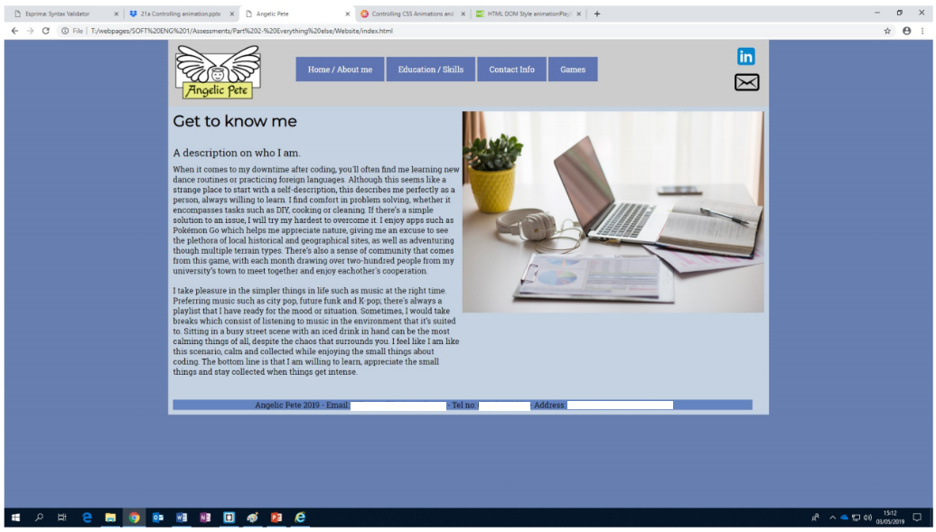

*The homepage of the website with a view size of around 1350px wide.*

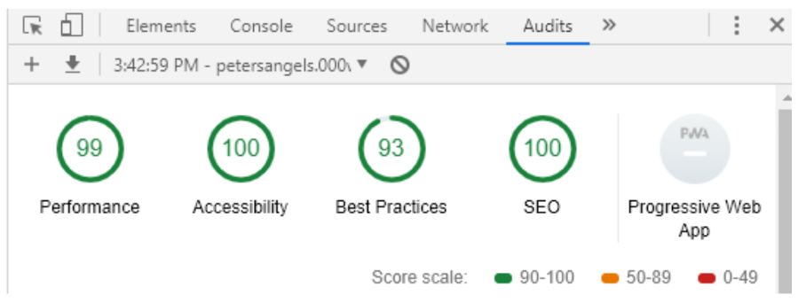

*The lighthouse score of the website.*

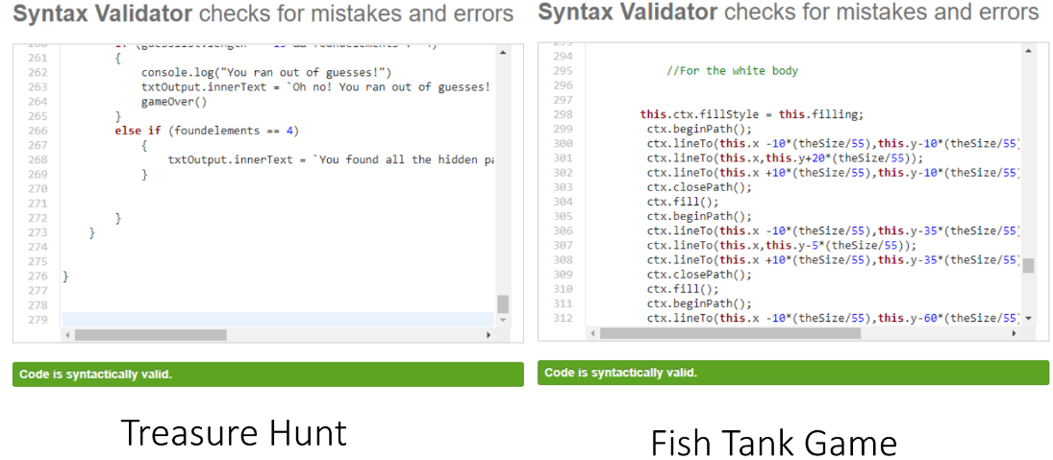

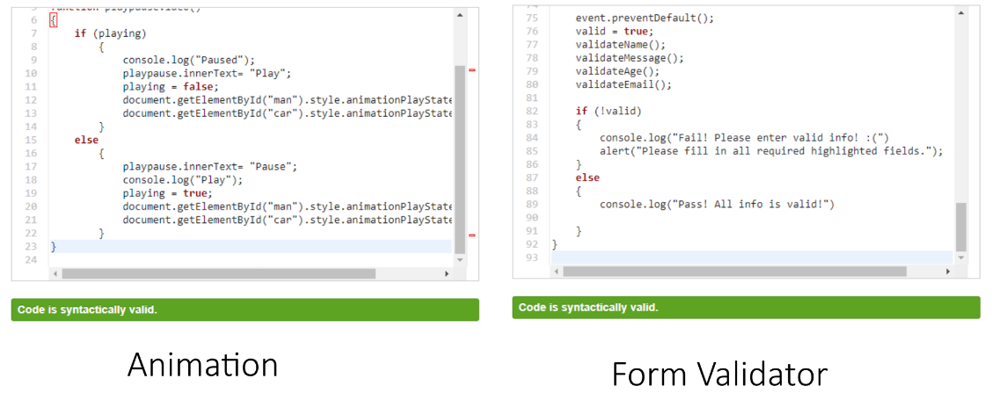

*The only existing screenshots of the Javascript code.*